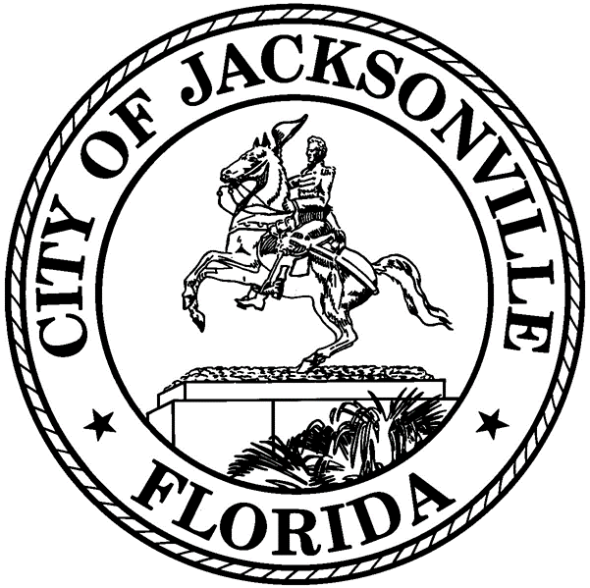
RULES COMMITTEE
REDISTRICTING PUBLIC HEARING

ATLANTIC COAST HIGH SCHOOL
February 3, 2022
6:00 – 7:30 p.m.

AGENDA
1) Call to order/welcome/hearing overview – Council Member Brenda Priestly Jackson, Chair - Rules Committee
2) Legal framework for redistricting – Paige Johnston, Chief of Legislative Affairs - Office of General Counsel
3) School Board redistricting perspective – Daryl Willie, Chair – Duval County School Board
4) Development of the redistricting proposal – Bill Killingsworth, Director of Planning and Development and expert consultant for redistricting
5) Public hearing
6) Concluding remarks - Council Member Brenda Priestly Jackson, Chair – Rules Committee
7) Future redistricting public hearing dates and locations (all from 6:00 – 7:30 p.m.)

- February 10, 2022 – First Coast High School
- February 17, 2022 – William Raines High School

